EVACUATION MAP

All occupants of an RV space should maintain their RVs so that they are mobility ready in case of evacuation. In case of emergency where an evacuation is safe and necessary, the order is as follows:

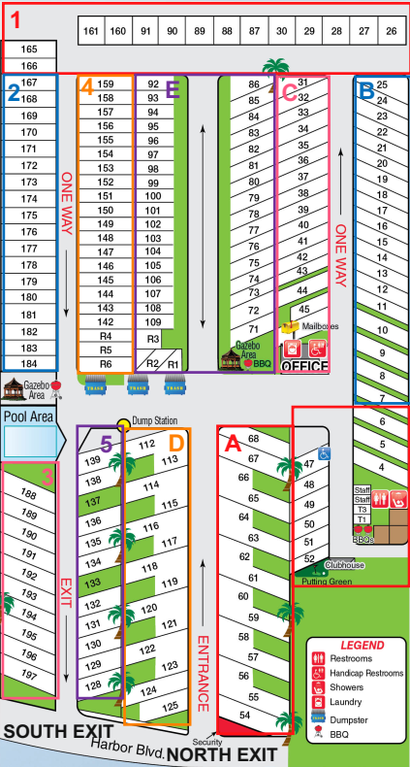

*for the full disaster guide*

*EVACUATION THROUGH SOUTH EXIT ONTO HARBOR BOULEVARD*

COLOR ORDER SPACE NUMBERS

RED 1 26 to 30

87 to 91

160 to 166

BLUE 2 167 to 184

PINK 3 188 to 197

ORANGE 4 142 to 159

r4 to r6

PURPLE 5 128 to 139

*EVACUATION THROUGH NORTH EXIT ONTO HARBOR BOULEVARD*

COLOR ORDER SPACE NUMBERS

RED a 4 to 6, 47 to 69

BLUE b 7 to 25

PINK c 31 to 45 and office

ORANGE d 112-125

PURPLE e 71 to 86, 92 to 109

r1 to r3